EXPERIMENT1:DATA PROCESSING IN GIVEN DATASET
AIM:
To perform data preprocessing using Python to clean the dataset, handle missing values, remove duplicate records, and prepare the data for machine learning.

ALGORITHM:
• Step 1: Start.
• Step 2: Import the Pandas library.
• Step 3: Load the dataset using the read_csv() function.
• Step 4: Display the dataset using the head() function.
• Step 5: Identify missing values using the isnull() function.
• Step 6: Handle missing values using the fillna() function.
• Step 7: Remove duplicate records using the drop_duplicates() function.
• Step 8: Display the preprocessed dataset.
• Step 9: Save the cleaned dataset using the to_csv() function.
• Step 10: Stop.
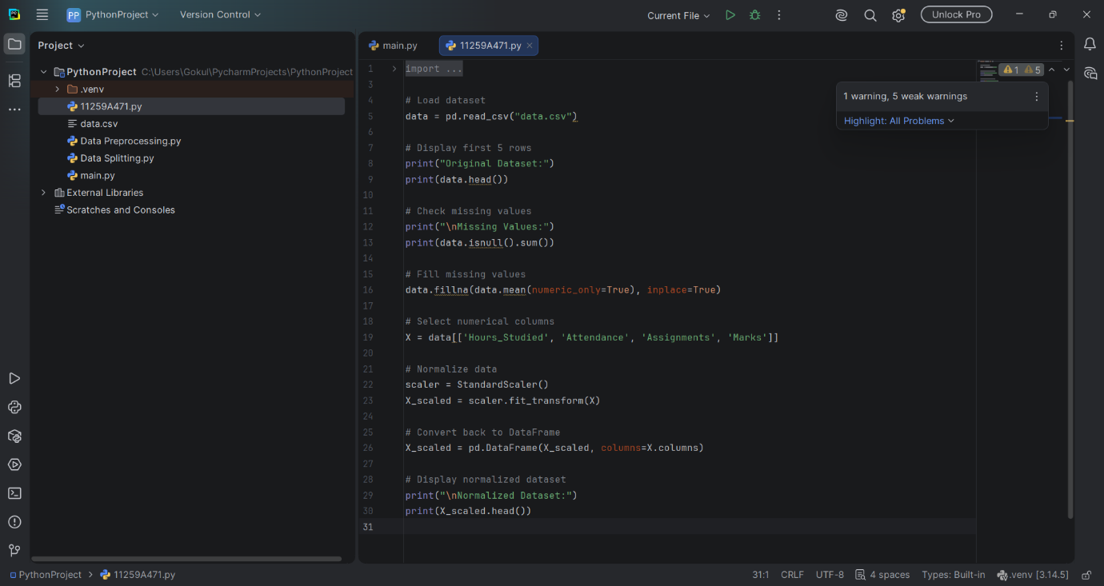

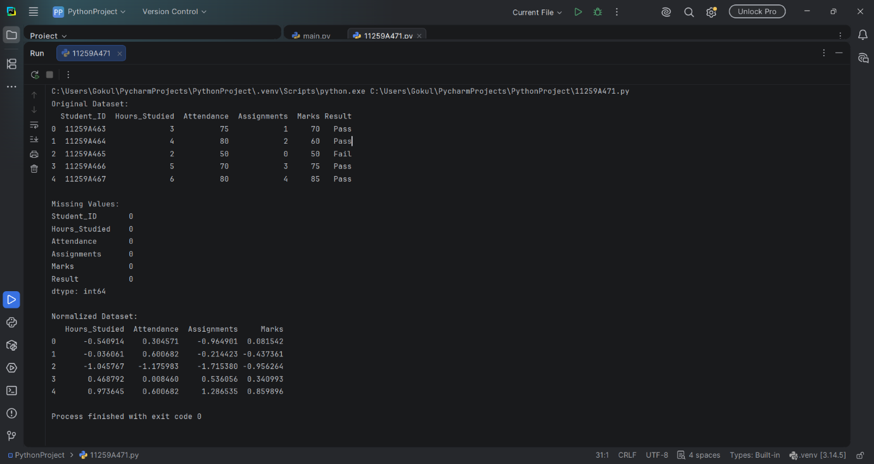

RESULT:
Thus, data preprocessing was successfully performed using Python by handling missing values and removing duplicate records from the dataset.

